Grace Summit

Strengthening our WHY

Monday, October 21, 2019

9:00 Registration

9:30-2:30 pm

Father Leduc School, Leduc

**.**

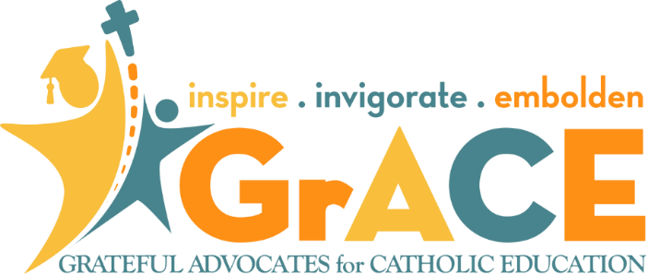

* Learn about advocacy for Catholic Education in Alberta
* Receive practical advocacy ideas and tips
* Share with other stakeholders
* Be inspired! Be invigorated! Be emboldened!

Register until Monday October 14 at [starcatholic.ab.ca/faith/grace](http://starcatholic.ab.ca/faith/grace)

Best Western Premier Denham Inn & Suites

Special Rate $109.00 855-479-0732

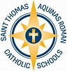

$25 Registration includes lunch

**Father Leduc Catholic School**

**400 Sheppard Boulevard**

**Leduc, AB**